**System Design**

**Introduction:**

* **System Analysis:**

The system analysis approach emphasises a closer look on all parts of the system. The analyst must consider all the system elements, their inputs, outputs, control, feedback and the environment when the system is being constructed.

* **System Design:** The goal of system design phase is to produce a model or representation of the system, which can be used to build the system. Here the emphasis is on translating the requirements of the system into design specification.

1. **Applicable Documents:**

The document used in system design is Software Requirement Specification Document.

1. **Functional Decomposition:**

The system can be decomposed into functional components as follows.

The Components are–

* This system helps customers to place orders through online also eases the workload on the staff of gift shop. This system will make things easier for staff as the entire ordering process is done by customers only.
* As most of the things will be performed online, it will reduce the usage of paper for the gift shop.
* Online Gift Shop system is a web based application which enables customers to order gifts through online for home delivery or to any given address.
* It would be much more comfortable for the customers to have an Online Gift Shop. It would be hassle free for users as they can select the gift they want and make payment for it. Also it will reduce the purchasing time for customers.
* This system will help customers in ordering custom gifts. So the customer will pick exactly the things which he/she wants in their gifts. This will surely enhance the image of the gift shop and customer satisfaction will be more.
* This system will give option to the customer for online payment.
* This system will provide customer all the details of his order before making order. This confirmation will help customers to check the items ordered with their prices.
* This system will show the time by which the order will be delivered to the customer. For pick-ups customers can fix the time by which they will pick their order.

1. **Program Description:**

**3.1 Data Flow Diagram**:

A data flow diagram is a graphical representation of the flow of data through an information system. A data flow diagram can also be used for the visualization of the data processing. It is a common practice for a designer to draw a context level DFD. It shows the interaction between the system and the outside entities. This context level DFD, is then exploded to show more detail of the system being modeled.

A DFD represents flow of data through a system. Data flow diagrams are commonly used during problem analysis. It views a system as a function that performs the input into the desired output. A DFD shows movement of data through the different transformations or processes in the system.

Data Flow diagrams can be used to provide the end users with the physical idea of where the data they input ultimately has an effect upon the structure of whole system from order to dispatch to restock how any system is developed can be determined through data flow diagram. The appropriate register saved in database and maintained by appropriate authorities.

**Notations in the DFD:**

|  |  |
| --- | --- |
| **Symbol** | **Description** |
|  | The circle or bubble represents a process. A process is named and each process is represented by a named circle. |
|  | The source or sink is represented as a rectangular box. The source or sink is the net originator or the consumer of the data that flows in the system. |
|  | The arrow represents the flow of data through the system. The labeled arrows enter or leave the bubbles. |
|  | The database is represented with the open box symbol. |

**3.2 Context Flow Diagram**:

Context flow diagram is a top level data flow diagram. It only contains one process node that generalises the function of the entire system in relationship to external entities. In context diagram the entire system is treated as a single process and all its inputs, outputs, sinks and sources are identified and shown.

**Context Flow Diagram (Level 0):**

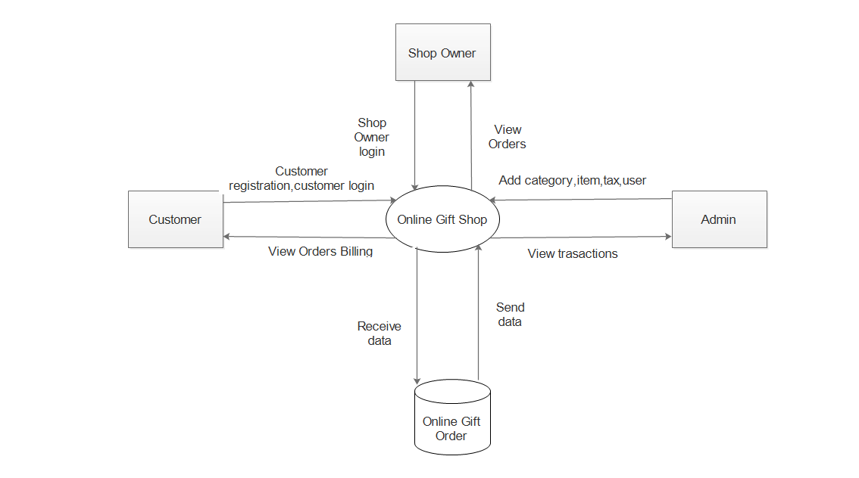

**Top Level DFD - Level-1**:

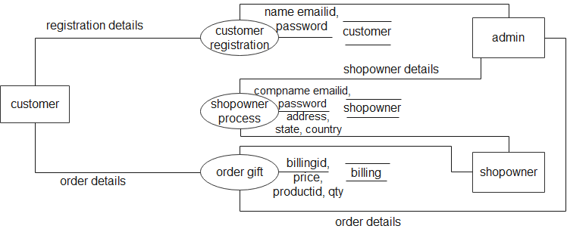

**DFD Level 2:**

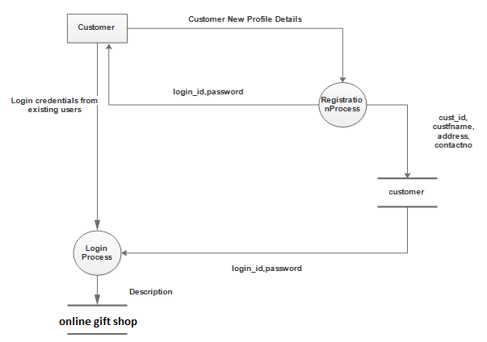

**Description of component:**

* **Input** :
* Customer registration details
* Login credentials
* Profile details
* **Process Definition:**
* Registration process
* Login process
* Update profile
* **Output definition:**
* The registration detail stores in customer table
* After the login the customer can view account page
* Customer can update their profile in profile module

**DFD Level 3:**

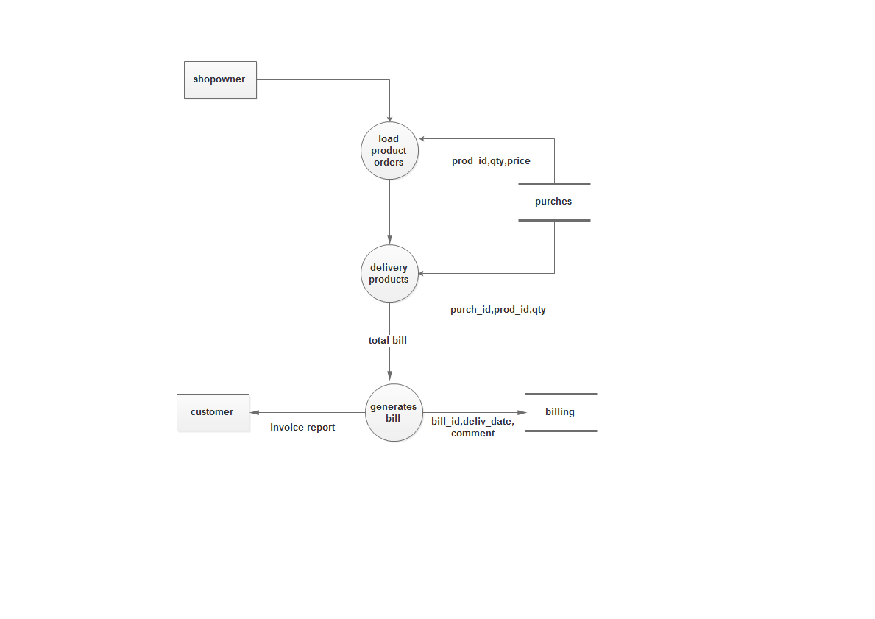

**Description of component:**

* **Input** :
* Shopowmer detail
* Cart detail
* Order detail
* **Process Definition:**
* Viewing shopowner profile
* Adding the products
* Adding the discount
* Generating the bill
* **Output definition:**
* The shopowner views their profile
* Adds the products to the database
* The customer can purchase the products added by the shopowner
* Before purchasing customer can apply to avail discount
* After the gift order and payment process billing detail stores in billing table and customer can download billing receipt.

**DFD Level 5:**



**Description of component:**

* **Input** :
* Image path of gift design
* Product requirement details
* **Process Definition:**
  + Loading product details
  + Adding product to cart
  + Order approval process
  + Make payment process
* **Output definition:**
* The customer views various products of different categories
* To purchase the product customer must add the selected product to the cart and make the payment.
* Products ordered by the customer can be viewed bythe shopowner and the admin.
* The gift order detail stores in billing table and billing receipt will be sent to the customer